------------------------------------------------------------------------------------------------------------------------

## Downloading relevant data to nltk ##

import nltk

# following command opens a dialogue box which helps in

# downloading relevant data to nltk

nltk.download()

------------------------------------------------------------------------------------------------------------------------

Nltk possible POS tags:

|  |
| --- |
| POS tag list: |
|  |  |
|  | CC coordinating conjunction |
|  | CD cardinal digit |
|  | DT determiner |
|  | EX existential there (like: "there is" ... think of it like "there exists") |
|  | FW foreign word |
|  | IN preposition/subordinating conjunction |
|  | JJ adjective 'big' |
|  | JJR adjective, comparative 'bigger' |
|  | JJS adjective, superlative 'biggest' |
|  | LS list marker 1) |
|  | MD modal could, will |
|  | NN noun, singular 'desk' |
|  | NNS noun plural 'desks' |
|  | NNP proper noun, singular 'Harrison' |
|  | NNPS proper noun, plural 'Americans' |
|  | PDT predeterminer 'all the kids' |
|  | POS possessive ending parent's |
|  | PRP personal pronoun I, he, she |
|  | PRP$ possessive pronoun my, his, hers |
|  | RB adverb very, silently, |
|  | RBR adverb, comparative better |
|  | RBS adverb, superlative best |
|  | RP particle give up |
|  | TO to go 'to' the store. |
|  | UH interjection errrrrrrrm |
|  | VB verb, base form take |
|  | VBD verb, past tense took |
|  | VBG verb, gerund/present participle taking |
|  | VBN verb, past participle taken |
|  | VBP verb, sing. present, non-3d take |
|  | VBZ verb, 3rd person sing. present takes |
|  | WDT wh-determiner which |
|  | WP wh-pronoun who, what |
|  | WP$ possessive wh-pronoun whose |
|  | WRB wh-abverb where, when |
|  |  |
|  | ''' |

------------------------------------------------------------------------------------------------------------------------

Named Entities:

ORGANIZATION – Google Inc.

PERSON – President Obama

LOCATION – Mount Everest

DATE - June

TIME – two fifty am, 1:30 pm

MONEY – 175 million dollars, GBP 10.40

PERCENT – twenty pct, 18.75

FACILITY – Washington Monument

GPE – South East Asia.

-----------------------------------------------------------------------------------------------------------

Naïve Bayes O/P

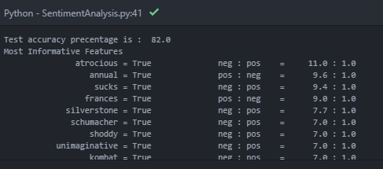

Interpret - Atrocious appears 11 times more often in negative reviews.